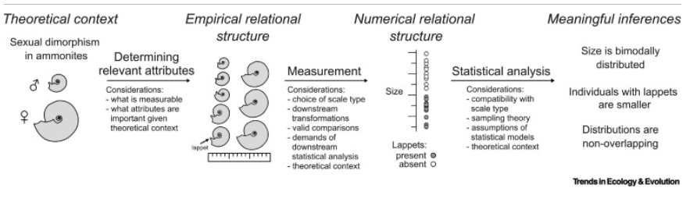

Theoretical Context
Context and Questions:
The research question pertaining to my data is what proteins in the phloem of Arabidopsis plants are differentially abundant across mock-, Pst-, and Pst avrRpt2-induced plants? Additionally, I recently became interested in what proteins are more or less abundant in Pst avrRpt2-induced plants relative to Pst-induced plants. This second question builds on recent literature demonstrating that induction of effector-triggered immunity (ETI) potentiates pathogen-associated molecular pattern (PAMP)-triggered immunity (PTI) in plants. Therefore, I hypothesize that for a SAR-associated protein, there may be a stronger effect on the abundance of a protein in response to Pst avrRpt2 (PTI+ETI) than in response to Pst (PTI).

Determining Relevant Attributes:
To determine what proteins are differentially abundant in the phloem of Arabidopsis plants induced for SAR, protein identity and quantity was measured in phloem sap of mock-, Pst-, and Pst avrRpt2-induced plants. This data was generated from phloem exudates collected from mock-, Pst, or Pst avrRpt2-induced plants. The collected samples were concentrated and subjected to liquid chromatography tandem mass spectrometry (LC-MS/MS) to identify phloem-localized proteins.

For each treatment, the following aspects of the phloem protein contents are measured. Unique peptide counts, which is the number and abundance of unique peptides detected from LC-MS/MS for each protein. Abundances of each unique peptide related to a specific protein were then used to calculate normalized protein abundances, which is a quantitative measure of protein abundances used for subsequent analysis. Since we are interested in identifying differentially abundant proteins in the phloem exudates, these measurements are critical.

Additionally, using public databases, we can introduce data on protein localization and gene ontology terms to measure the distribution of detected proteins based on subcellular localization and known or predicted functions, respectively. These attributes are important given the context, as we expect proteins important for SAR signaling have a function in biotic stress responses and are localized to the apoplast or cytosol. Since this work is discovery-oriented, these may also reveal interesting groups of proteins if there is differential abundance of proteins belonging to a specific GO term or subcellular localization across treatments.

Measurement

Scale Types:
Unique peptide counts = ratio scale
Normalised protein abundances = ratio scale
Gene Ontology information = nominal scale
Subcellular localization = nominal scale

Acceptable transformations, valid comparisons, demands of downstream analysis:
Unique Pepide Counts: It is unlikely that any transformations would be performed on the unique peptide count data, as its meaning is directly associated with its absolute number. A standard practice in filtering proteomics data is to remove any proteins that have only 1 unique peptide attributed to them. I have seen arguments against the use of the 2-peptide rule, and methods that take into account the protein size to allow inclusion of proteins with less than 2 unique peptides. I may try to employ one of these methods to avoid losing small proteins that may be biologically significant, but this may be ambitious for my skill level and understanding.

Normalized protein abundances: It is common to perform log transformations on the normalized protein abundance data, and this is acceptable to do, as it is a ratio scale measurement. One may be inclined to use a log₂ transformation and report log₂ fold-change to make interpretation of fold change easier and symmetrical. Another benefit of log₂ transforming the data is to help make variances more constant and transform the data to a more normal distribution. Downstream statistics include Welch’s t-test, which does not assume equal variances. This demands that the population from which the data samples are drawn be independent, follow similar distributions, and follow a normal distribution. This test is also compatible with ratio scale-type data.

Subcellular Localization and GO terms: For gene ontology terms and subcellular localization, since these are on the nominal scale and categorical, the only transformations that are appropriate are one-to-one mappings. The meaningful statistics that can be done with this data include counts and percentages based on counts. This data can be used to test for enrichment of certain GO terms or subcellular localization of proteins in the whole data, and subsets of the data using Fisher’s Exact test. Fisher’s exact test can be used on the counts to determine enrichment of proteins based on subcellular localization or gene ontology information. Nominal-type categorical data, like subcellular localization or GO term counts suit Fisher’s exact test as the test assumes the data is categorical, and observations are independent, which is true.

Statistical Analysis

Determination of differentially abundant proteins:

Typically, a student's t-test has been employed to determine statistically significant differences in protein abundances between two treatments. Often, Welch’s t-test is used as it does not have any assumptions of equal variance, which proteomics data do not have. I am also considering use of a moderated t-test to assess statistically-clear differences with this data using an R package called limma, but I need more time to learn about this. Given the theoretical context, since we do not know if biologically important proteins are expected to be more or less abundant, a two-tailed t-test should be used. If I decide to assess statistically clear differences between the Pst and Pst avrRpt2-induced proteomes, I would need to use an ANOVA and a post-hoc test instead.

Authors will often set an arbitrary threshold such as a log₂FC ≥ 土 1 (i.e., 2-fold change), as biologically significant changes in abundance, assuming statistically clear differences are observed. Since I am interested in identifying proteins that may contribute to long-distance signaling, small increases in protein abundance relative to mock could be biologically significant. Although a 2-fold change is the most standard threshold set for filtering data for biologically significant proteins, a 1.3-fold change has also been used for more subtle changes. Assuming a difference is statistically clear, I will employ a cutoff at a 1.3-fold change for determining if a protein is differentially abundant at a biologically meaningful level.

